A000-CAN-NW Coast-Shaman’s Mask-Four Eyes-White Hair-19th century

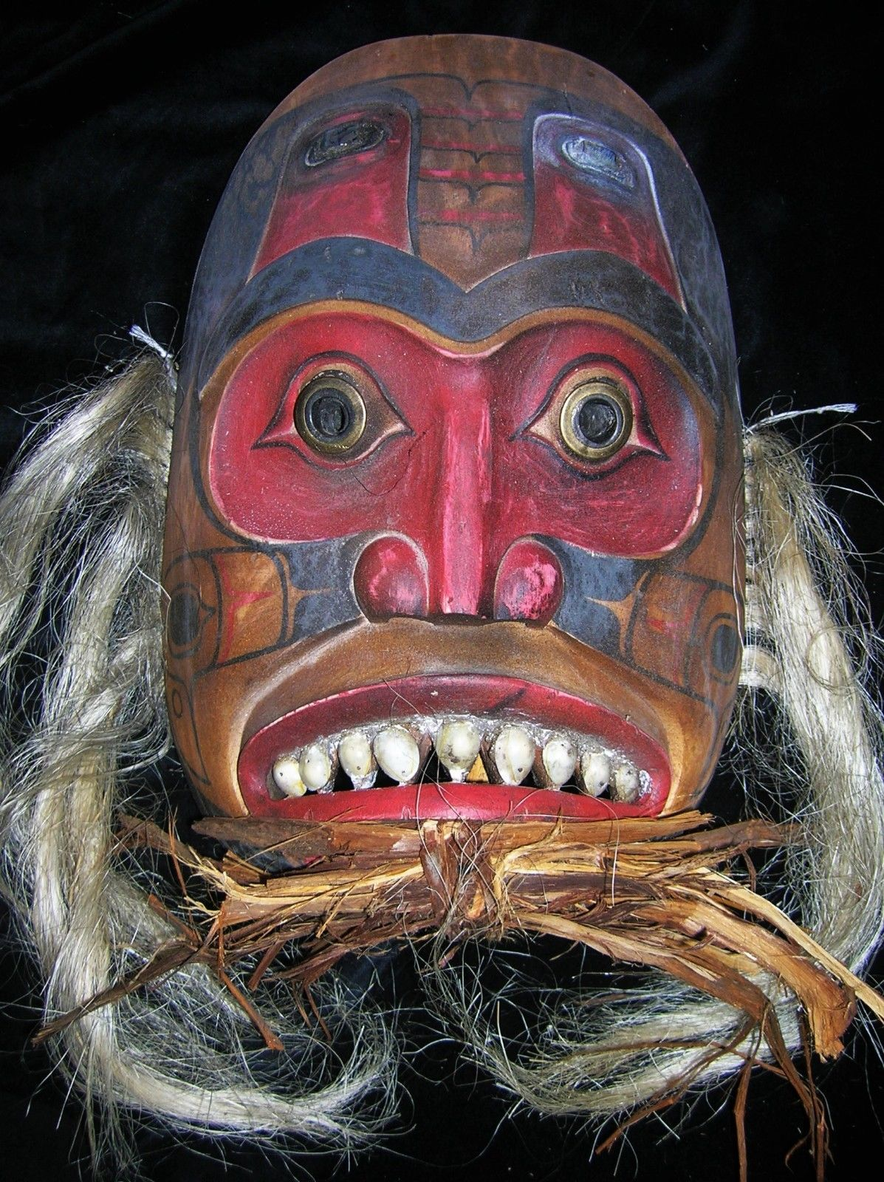

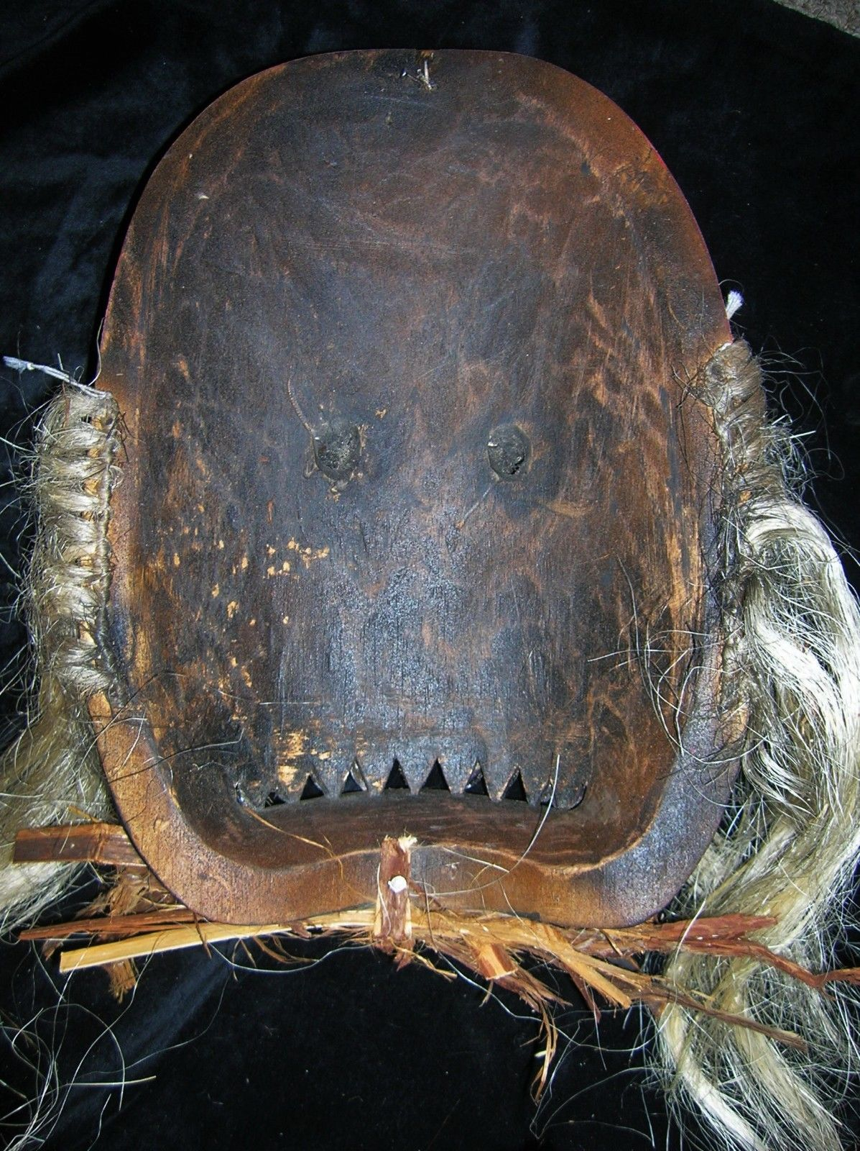

Figs. 1-2. CAN-NW Coast-Shaman’s Mask-Four Eyes-White Hair-19th century

Case No.: 8

**Accession No.**

**Formal Label:** CAN-NW Coast-Shaman’s Mask-Four Eyes-White Hair-19th century

Case No.: 8

Accession No.

Formal Label: CAN-NW Coast-Shaman’s Mask-Four Eyes-19th century

Display Description:

The two 2 sets of eyes to enhance the Shaman's perception are unique.

LC Classification:

Date or Time Horizon:

Geographical Area:

Map:

GPS coordinates:

Cultural Affiliation:

Media: Copper lower eyes and fish eyes of abalone shell, on forehead, operculum teeth, human hair.

Dimensions:

Weight:

Condition:

Provenance: Signed "Bear Thompson" Many years of shamanic use and wonderful patina. EX Robert Cornell estate in Ludlow MA